1. 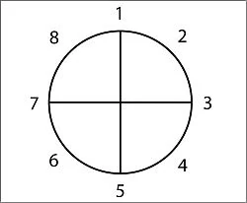A character is in a zone of comfort;
2. But they want something;
3. They enter an unfamiliar situation;
4. Adapt to it;
5. Get what they wanted;
6. Pay a heavy price for it;
7. Then return to their familiar situation;
8. Having changed.

Game Title Ideas:

Matter

Shutdown

Generator

Shaper

Detailed Story:

1. Player wakes up in his house, learns how to move by taking the character to the door and learns how to interact with objects by opening the door.

2. All the light in the city shuts down and a crowd of people gathers discussing what happened. Its decided that someone needs to go down to the geothermal generator that powers the town and repair it. No one has been down there for a very long time and all people know is that it was built to be secure and it’s hard to get there.

3. On the Floor 0 station there’s a note explaining how there are puzzles that need to be solved to reach the generator and there’s the matter gun with instructions on its purpose and how it works.

4. Every now and then at the entrance of the floor there’s a station with either story elements or some piece of new equipment;

5. Reaches the generator and fixes it;

6. Discovers the sun still exists and that they don’t need to live in the dome;

7. Go back home and talk to the people, some try to stop saying he will freeze the moment he opens the door of the dome;

8. He steps out and he is fine.

Puzzle mechanics:

Scannable objects that can be assimilated by the matter shaping tool and that can be shaped according to how much mass they have.